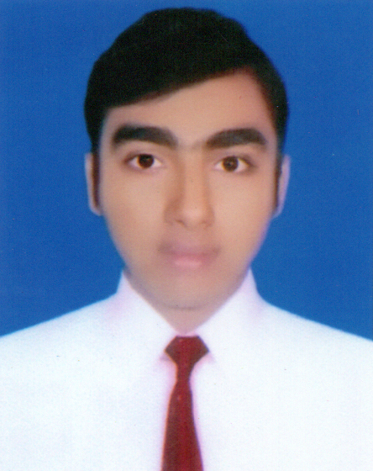

Resume of
Muhammad Abul Kalam Azad

Ashulia, Savar, Dhaka, Bangladesh.
Mobile: +88 01731185574, +8801559504351 | Email: akmnaym@gmail.com

CAREER OBJECTIVE

Practice morality in every action all around the life and like to develop career in job arena with highest potentiality and dedication and to be in superior position by performing the best.

EDUCATION QUALIFICATION

2017 Bachelor of Honors Degree (B.Sc.)
Hon’s (Statistics)
CGPA : 3.18
Tejgoan College, Farmgate, Dhaka
National University, Bangladesh.

2013 Higher Secondary School Certificate (HSC)
(Science group)
GPA : 3.40
Mirpur College, Mirpur, Dhaka

2011 Secondary School Certificate (SSC)
(Science group)
GPA : 4.44
Islamia Adarsha High School, Mirpur, Dhaka

PROFESSIONAL TRAINING

2019 Certificate On Professional Customer Service (PCS)

Skills For Employment Investment Program (SEIP),
Finance Division, Ministry Of Finance, Bangladesh

2015 Cetificate In Degital Marketing

BASIS Institute of Technology & Management (BITM)
Bangladesh Association of Software and Information Services (BASIS)
Finance Division, Ministry Of Finance, Bangladesh.
PERSONAL DETAILS

Father’s Name : Muhammad Nurul Islam Bhuyan
Mother’s Name : Fatema Akter
Marital Status : Single
Blood Group : A⁺
Date of Birth : 10 November 1995
National ID : 6892040111
Religion : Islam

CONTACT US

Family Mobile No. : 01818 962356

Permanent Address : Jafrabad Bhuyanbari, Puran bazar, Chandpur (sador),
Chandpur.

LANGUAGE EFFICIENCY
Have good command in speaking & writing Bengali & English

COMPUTER SKILLS

- Microsoft Office
- Internet browsing

PROFESSIONAL SKILL

- Team Leadership
- Professional Customer Service
- Digital Marketing

It was always my dream to work in an International Service and Commercial Organization. So that I could serve my country and as well as other countries of the world by assisting people for their better life. I am deeply convinced that the offer is the best way of concretizing this future because of its International orientations.

Thank you very much for considering my request. I look forward to your positive response.

Signature : _____________

